
Delhi Technical Campus Greater Noida
Assignment 2

Instructions:
- All questions are compulsory to attempt.
- Assignment must be submitted in handwritten manner in separate notebook.
- Submit the assignment on or before (Mentioned date).
- Marks will be deducted and analysed as per the submission dates. At late submission marks will be deducted.

Subject: Design and Analysis of Algorithm Subject Code: CIC-311
Class: B.Tech CSE 5th Faculty Name: Ms. Anshul
Date of Issue: 02/10/2023 Date of Submission: 10/10/2023

1 | a) Construct Huffman code for the following set of frequencies:  b) Compare fixed-length and variable-length codewords and the amount of saving took place. | CO2 | L4
   | a | b | c | d | e | f
  Frequency | 45 | 13 | 12 | 16 | 9 | 5
2 | Illustrate General method of Greedy method. Find the greedy solution for following job sequencing with deadlines problem n = 7, (p1,p2,p3,p4,p5,p6,p7) = (3,5,20,18,1,6,30), (d1,d2,d3,d4,…,d7) = (1,3,4,3,2,1,2) | CO2 | L3
3 | Examine single source shortest path for the following graph using Dijkstra’s algorithm. Assume node 1 as source. Also analyze time complexity of Dijkstra Algorithm.  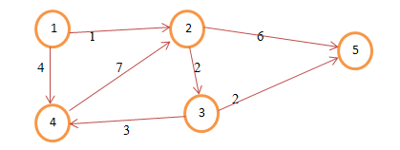 | CO2 | L3
4 | Explain 8-Queen’s problem can be solved using back tracking and explain with an example. | CO2 | L2
5 | Summarize how to find the existence of Hamiltonian cycle in graph? Write the algorithm and explain with suitable example. | CO1 | L2

